Oppgaver
- Hva er viktig for livssynshumanistene?
De mener at ___________________________________________________________
__________________________________________________________________________________________________________________________________________

- Hva betyr HEF?
H står for _____________________________
E står for _____________________________
F står for _____________________________

- Hvilke humanistiske seremonier ser du på bildene? Skriv om den seremonien du ser på bildet.
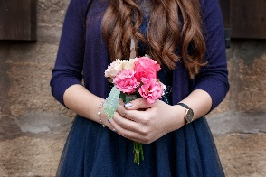
Bilde: Adobe Stock, CreaFoto
_______________________________________________________________________________________________________________________________________________________________________________________________________________
_____________________________________________________________________

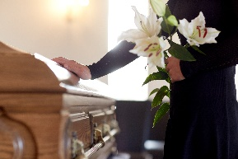
Bilde: Adobe Stock, Syda Productions
_______________________________________________________________________________________________________________________________________________________________________________________________________________

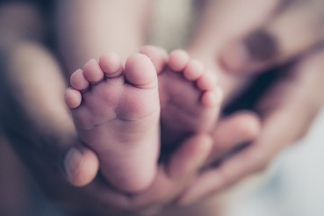
Bilde: Adobe Stock, Simon Dannhauer
_______________________________________________________________________________________________________________________________________________________________________________________________________________

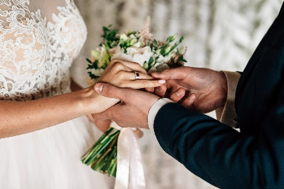
Bilde: Adobe Stock, Viktar Vysotski
_______________________________________________________________________________________________________________________________________________________________________________________________________________

- Skriv inn videre med egne ord det du har lært om livssynshumanismen
- Alle er verdifulle.
- Samme rettigheter og plikter.
- Alle må ha det godt.
___________________________________________________________________________________________________________________________________________________________________________________________________________________________________________________________________________________________________________________________________________________________________________________________________________________________________________________________________________________________________

