AYNISINI YANINA YAZ
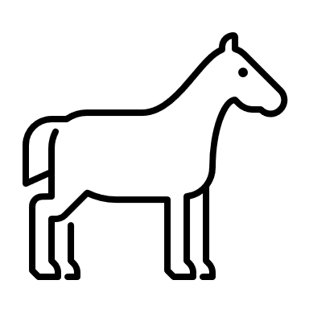 | AT | _____________ | 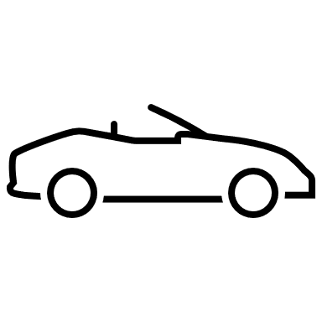 | ARABA | _____________
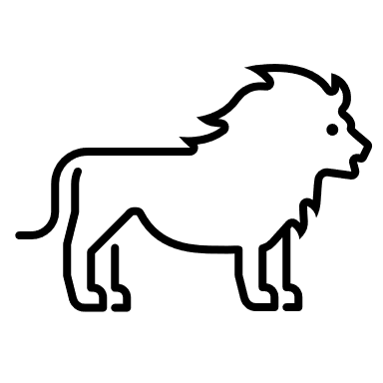 | ASLAN | _____________ | 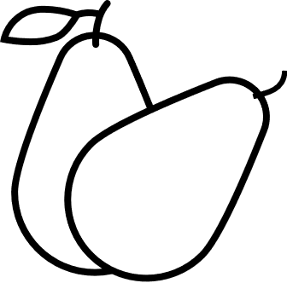 | ARMUT | _____________
 | AYI | _____________ |  | ARI | _____________
 | AMPÜL | _____________ |  | AYNA | _____________

BULMACA
A harfleri ile başlayan isim bulmacası
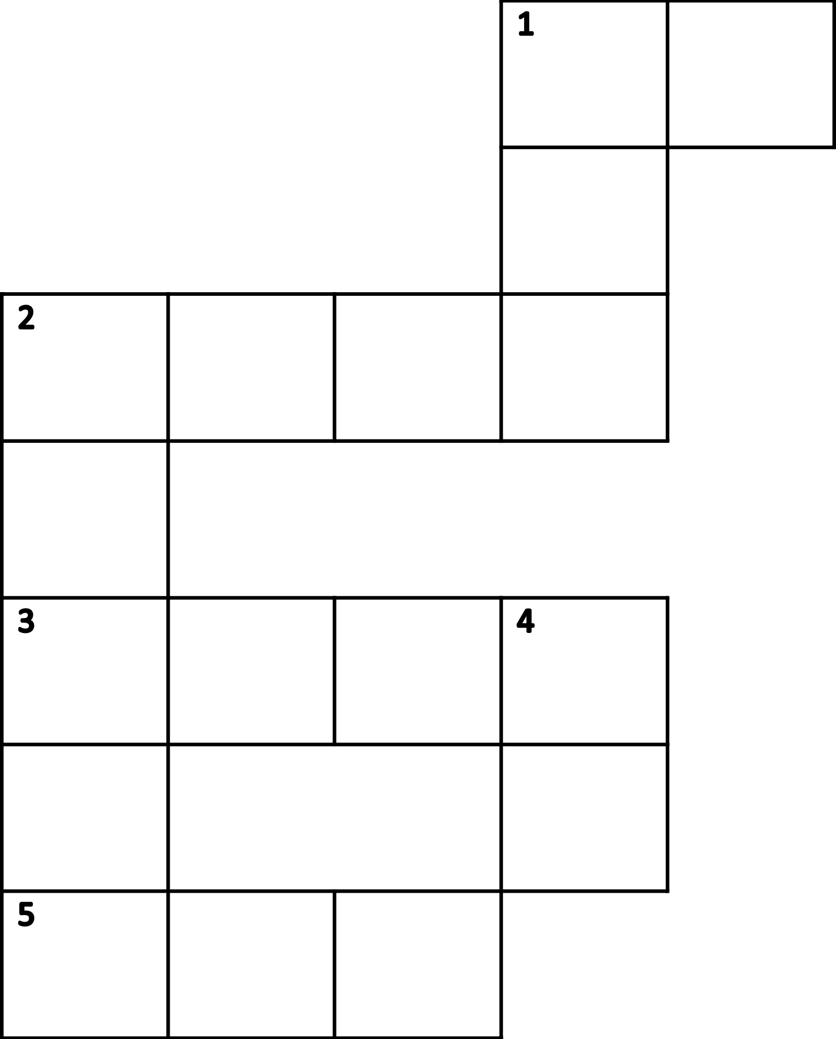
 |  | Soldan sağa
1 |  | _________________________________________
2 |  | _________________________________________
3 |  | _________________________________________
4 |  | _________________________________________
 |  | Yukarıdan aşağıya
1 |  | _________________________________________
2 |  | _________________________________________
3 |  | _________________________________________

