The United Nations (UN)

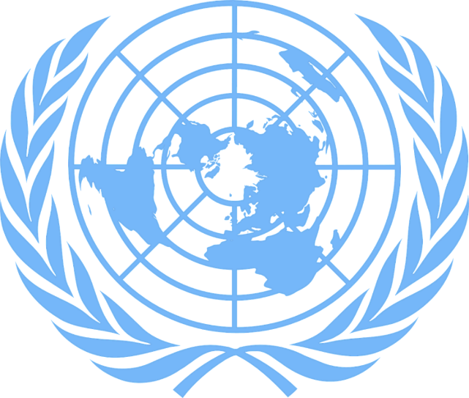
The UN's logo (pixabay.com).

The UN is short for United Nations, and it is an organisation that works to maintain peace on earth.

What is the UN?
There was a world war from 1939 to 1945. Many countries across the world were involved. The war is known as World War II. Many places were destroyed and many people lost their lives. Many people were therefore afraid of a new world war. The world needed someone who could stop another great war. The UN was therefore founded in 1942 to maintain peace on earth. In Norwegian, the UN is called FN – De forente nasjoner.
The UN made an agreement called the Charter of the United Nations. It is an agreement that decided the tasks of the UN and how it was going to perform these. Norway and 50 other countries signed the UN Charter. The UN started work on these tasks on 24 October 1945. United Nations Day is therefore celebrated every year on 24 October across the world.
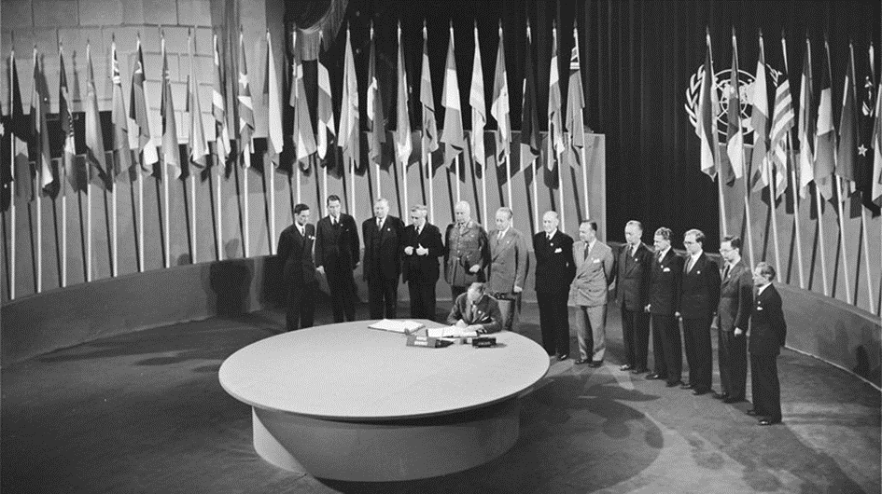
Photo: Signing of the UN Charter (fn.no).
In 2020, 193 states are members of the UN, and the UN's headquarters are located in the city of New York in the USA.
Today, many UN member states speak different languages. To make sure that everyone understands and can express their views, meetings and documents are translated into different languages.
The UN logo has five circles and a white map of the world where the North Pole is in the middle of the map. There are two olive branches around the world map. This is a symbol of the UN's goal to maintain peace and security in the world. Many schools put up the UN flag on 24 October. The flag is blue with the logo in the middle.
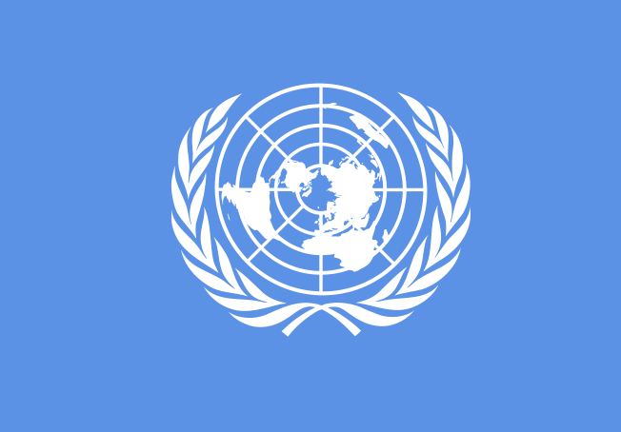
Photo: The UN’s logo (fn-filuren.no).

What does the UN do?
The UN wants the world to be a better place for everyone. It wants to:
- Maintain international peace and security
- Make sure that all countries comply with human rights
- Ensure sustainable development
- Work on the UN's Sustainable Development Goals

Peace and security
The UN wants a safer world. That is why the UN talks to countries that disagree with each other. They talk together and negotiate without using weapons. Sometimes it is hard to cooperate. The UN can then decide to use military power to protect peace and security where there is conflict. In countries where there is war, the UN helps people who need to flee. The refugees are given water, food, medicine and a place to sleep.

Human rights
The UN makes rules and ensures that all countries follow the rules to make sure that all people have good lives.
It is important for the UN that everyone has the right to believe and say what they want. We call this freedom of religion and freedom of speech. Another important area that the UN works on is women’s human rights. Women should have the same rights as men to study and work, express their opinion and participate in politics.

For the UN, it is also important that all children have good lives, that they can go to school and have food and water. That is why the UN has drawn up separate rules for children, what children’s rights are and what children need to have a good life. These rules are known as the Rights of the Child.

Sustainable development
Sustainable development is about the climate, environment and protecting nature. People must use the earth in a better way. It is important that we take care of what we have so that people can continue living on earth for a long time. Today, children and adolescents think about sustainable development. They are good at thinking about the environment when they buy things and take care of nature. The UN agrees with this view.
The UN has created a plan called the UN Sustainable Development Goals. Having a goal means working to make something better. The UN wants to end poverty, ensure that all children have the right to go to school, to study, to work and express their opinion without being scared and that more people live in an environmentally friendly way. The aim is to meet these goals by 2030. There are 17 Sustainable Development Goals. The UN wants everyone in every country to work to create a better world.
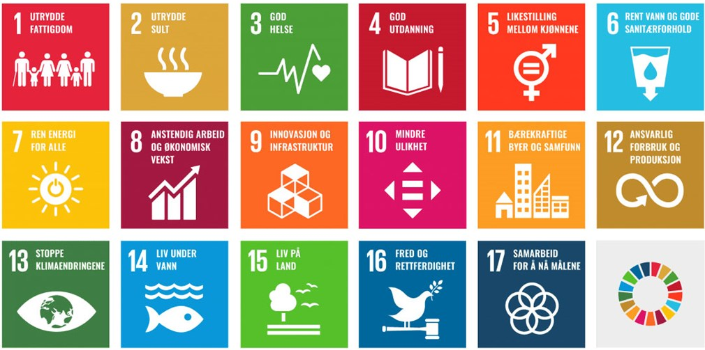
Read more about the UN’s Sustainable Development Goals on fn.no.

Who does what?
In order to ensure the UN can attend to all its tasks, the work has to be delegated. They have therefore established different groups. We call these groups bodies.

The General Assembly
The General Assembly is the main body in the UN. The General Assembly’s most important task is to discuss the world’s biggest challenges, decide what the UN needs to do and how to do it. The General Assembly is made up of one representative from each member state and every country can vote.

The Human Rights Council
When the UN was established, its most important task was to write down what everyone needs to live a good life. They called this idea human rights. The Human Rights Council's most important task is to make sure that all countries comply with the human rights and support countries that need help to comply with the human rights in a good way. The council has 47 members that are elected for three years at a time. The Human Rights Council meet in the city of Geneva in Switzerland.

The Security Council
The Security Council's task is to work for peace and security in the world. The council has 15 members. If there is a risk of major disagreements and conflicts in the world, the Security Council's task is to try to prevent an armed conflict. The council helps those in conflict to talk together to try to reach an agreement. This is called negotiations.

The UN Secretariat
The UN's work is managed by a body called the secretariat. Its task is to organise all of the UN's tasks. The person in charge of the secretariat is called the Secretary-General.
He or she also leads the whole UN.
The UN means a lot to Norway. One of the reasons for this is that the very first Secretary-General was Norwegian. His name was Trygve Lie. Do you know who the UN Secretary-General is today?
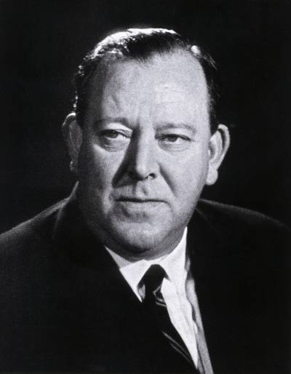
Photo: The first Secretary-General Trygve Lie (fn.no).

Exercises
- When and why was the UN founded?
- What is the UN Charter?
- On what day do we celebrate United Nations day and why is it celebrated on this date?
- How many member states does the UN have today?
- Where are the UN headquarters located?
- Who was the UN's first Secretary-General?
- What is the name of the current Secretary-General?
- What does the UN do?
- Can you use the internet to find out about four of the UN Sustainable Development Goals that you believe are important? Why do you believe these goals are important?

